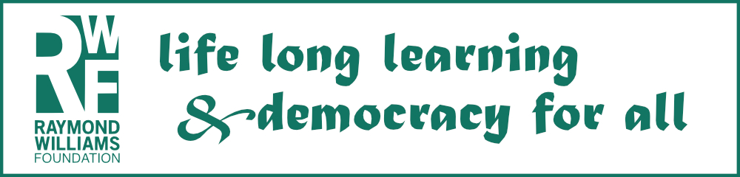
£1.5k RWF Targeted Grants scheme 2024
The RWF is open to applications for up to six targeted grants of up to £1,500 to support self-organised adult learning activities, or events, to help realise social justice aims and learning benefits.

Applications will be evaluated based on the quality of the proposed learning activity and its expected social justice benefits to individuals and wider society. The event or activities can have any progressive, social justice oriented, cultural or environmental focus relevant to problems and possibilities people are facing today, in their local communities or more widely.

Applications will be particularly welcome from individuals, or groups of people, who are currently under-represented in RWF’s activities – including those on low incomes/universal credit, younger people (under 25’s) and PoC.

You do not need to be part of a constituted group - e.g. a charity or Community Interest Company (CIC)) to apply – the RWF will welcome applications from individuals and grassroots groups.
The grant will be award 50% up front and 50% on successful completion.

DEADLINE FOR APPLICATIONS: Midnight Sunday September 22nd 2024 (please note: the RWF only operates in the UK)

RAYMOND WILLIAMS FOUNDATION
Registered charity number: 1126575

Application for a RWF Targeted Grant 2024
Email the completed form to raymondwilliamsfoundation@gmail.com

Name…………………………………………………………………………………………………

Address……………………………………………………………………………………………

…………………………………………………………………………………………………………

……………………………………………………………………………………………………….

…………………………………………………………………………………………………………

Post code…………………………

Telephone number………………………………………………………

email…………………………………………………………………………………………………

1. Please describe the self-organised adult learning event/activity you wish to organise and the social justice benefits for individuals and society you expect to help realise through doing this

2. Please provide a break-down of how you would expect to spend the grant, including an indication of the proposed timetable for the project (the project will need to be completed by September 2025)

3. Is this application being made on behalf of a constituted group (e.g. a charity or a Community Interest Company)? On behalf of grassroots group? Or are you applying as an individual?

4. Are you / the group you are applying on behalf of on a low income/universal credit? Are you / the group you are applying on behalf of under 25 years of age? Are you / the group you are applying on behalf of PoC?

